Rancho RS9000XL Shocks, Adjustable Shocks
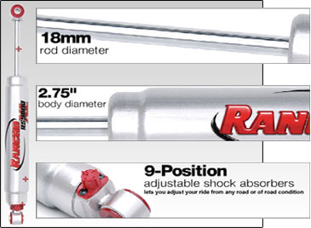 | • 2.75" Body Diameter  • 18mm Rod Diameter  • Liquid Metallic Finnish  • myRIDE 9-Position Manual / Remote System  • Rancho Red Polyurethane Bushings  • Protective Boot Included  • Limited Lifetime Warranty and 90-Day Free Ride Offer
Be the firest to expirence the new RS9000XL Shocks from Rancho. Dial your ride with Rancho RS9000XL! RS9000XL shocks give you total control over the ride quality of your truck or sport utility vehicle. With a simple fingertip adjustment, tailor the ride of your vehicle for comfort on the road, and ultimate control in the most demanding off-road conditions.
